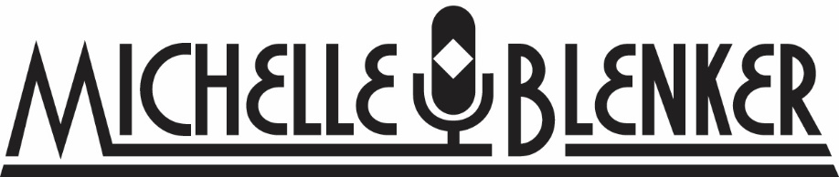
Voice Over List
COMMERCIALS:

Jeromes Furniture
Red Envelope Gift Company
Harvoni
Budget Blinds
Seton Medical Group
Bower’s Jewlers
Wet N Wild Amusment Park
Stella and Allure
Athens’ Greek Market
Coburn’s Delivers
Desert Lexus
Western Federal
Masterpeice Initiative
Hair Benders International
Everybody Suffers
Windward Academy
Ann Karen Day Spa
Three River’s Dental
Greater Texan Health
Kids Corner
Pittsburg Public Schools
Windmill Bakery
Abbott Transportation
Southern Muse
Jessica Rabbit
Superior Float Tanks
The Care Equation
Emerald Properties
Prestige Auto
Stater Brother’s
Casa Colina Hospital
Personal Creations (National)
R&J Boutique
Freedom Plaza
Pier 1 Imports
Mathnasium
Bright Buddies Pima Medical Institute
PMI-Renton Campus Russian Football Championship
Ugears Thomas Law
St. Jude Hospital Mathnasium
UBEO River to River Resdentia
Sunset Ranch SeoulScrub

AUDIO BOOKS:
The Onion
Once Again: A Coming Home Short Story, Book 2
Coming soon: I Know Your Name (Fall 2018)

E LEARNING:

Traffic Safety Courses:
The State of Indiana
The State of Tennessee
Truck Lift Safety Cours

PROMO/In Show Narration:
Hollywood News Feed (2012-Present)
Hollywood On Set (2012-Present)
Zoom IN (2012-2Present)

DOCUMENTARIES; IMDB Credit
A&E Movie Channel O.J. Speaks; The HiddenTapes: News Reporter
The Secret Tapes of the O.J. Case: The Untold Story: Nicole Brown Simpson, News Reporter

NARRATION:
Canaday Presents: The Lee Ann Canaday Show.
T. Rowe Price
Fanatsy Flight Games: Mansions of Madness: Streets of Arkham & Ill Fated Exhibit

MESSAGE ON HOLD:

Ace Electric
Chesterfiled Restaurant
Classic Collision
Missouri Table and Chair
Moppert Brothers Auto
Williamsburg Dental
Atlanta Dent
Hodge and Langly
Gastroenterology Specialties
Great Plains Communications
Safe Parenthood Malaysia
Fran-Rock
Hulihan’s
Intabag
North Jersey Diabetes and Endocrinology
Rolling Hills Animal Hospital
Z Real Esate
Melissa Data
Albany Motorcars
The Property Shop

